Execute SQL Queries for any dataset
Dataset
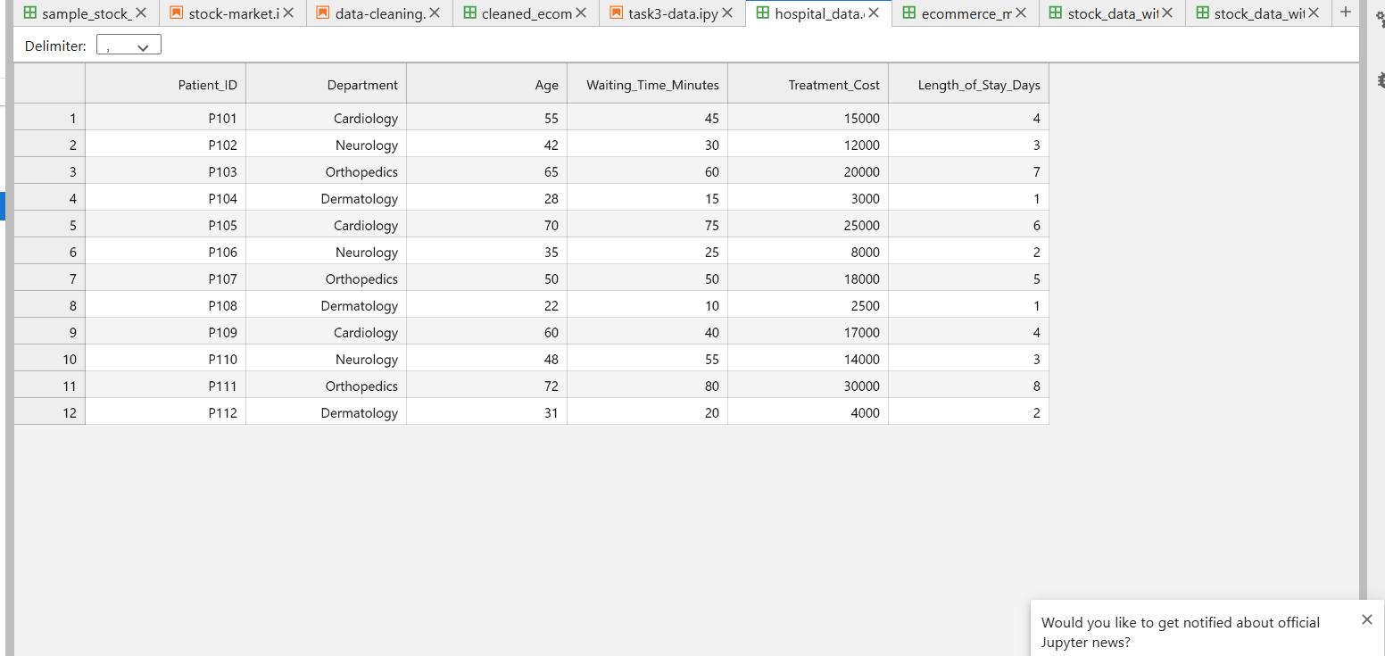
For this hospital dataset we have the following tables and relationship
Relationship | Parent table | Child table | Foreign key
One-to-many | Departments | Patients | Patients.Department_ID
One-to-many | Patients | Appointments | Appointments.Patient_ID
One-to-one | Patients | Medical_Records | Medical_Records.Patient_ID with UNIQUE
Many-to-many | Patients | Doctors | Patient_Doctor junction table

Inserting all the datas
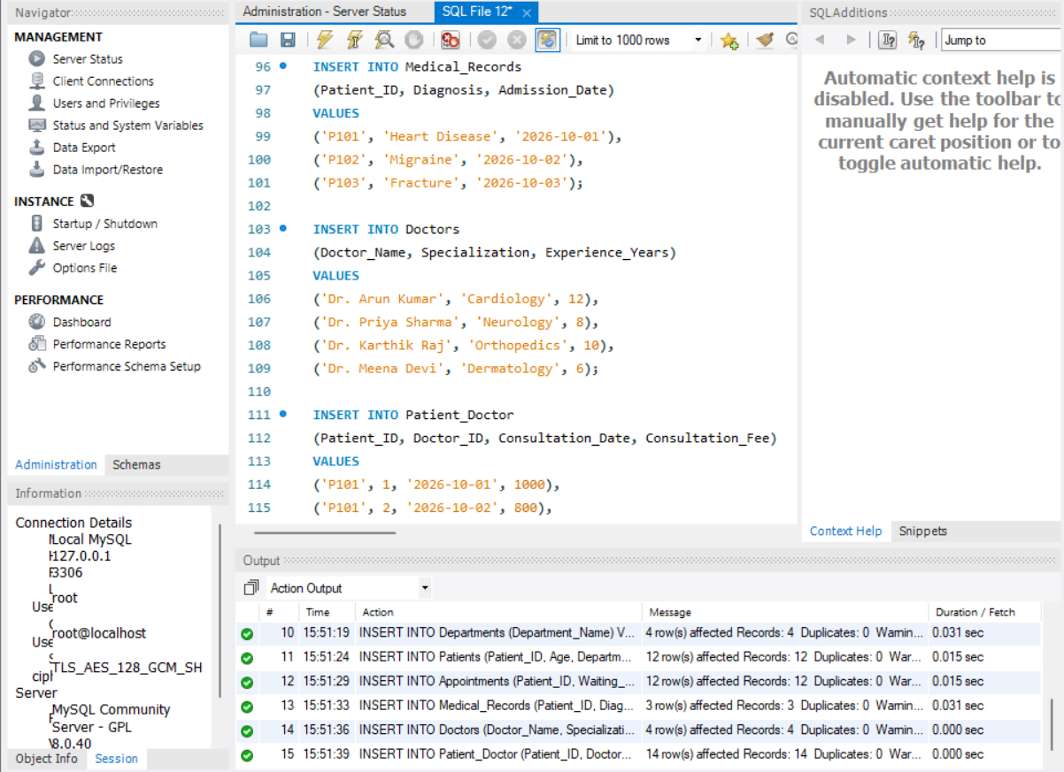
1. Visualizing the full database
Query :
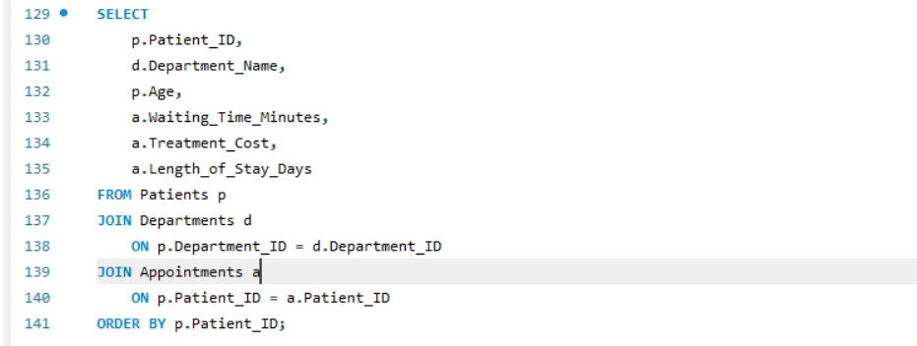
OUTPUT :
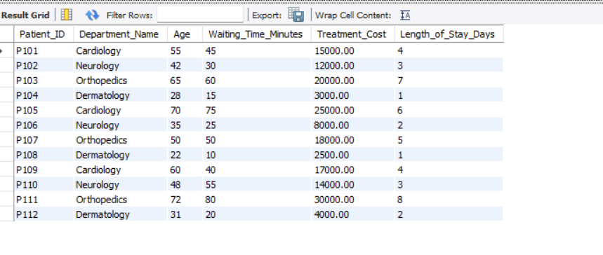
2.QueryOutput:
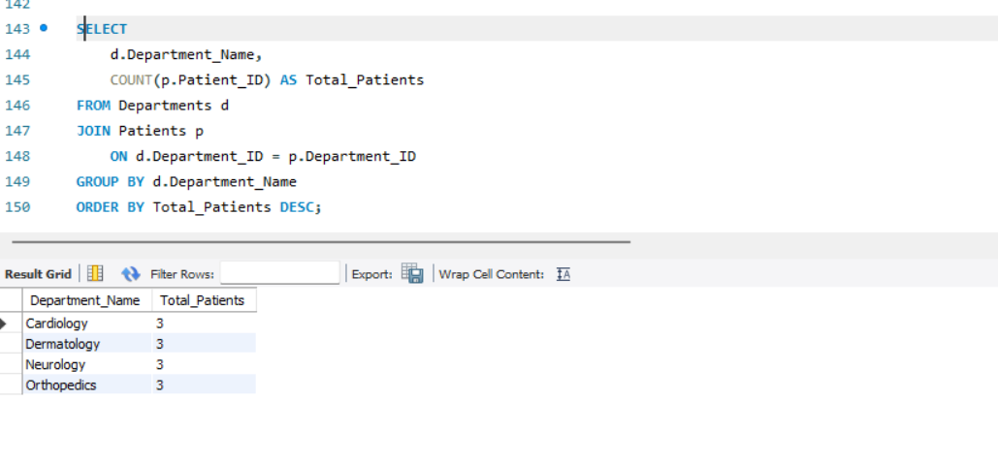
3.
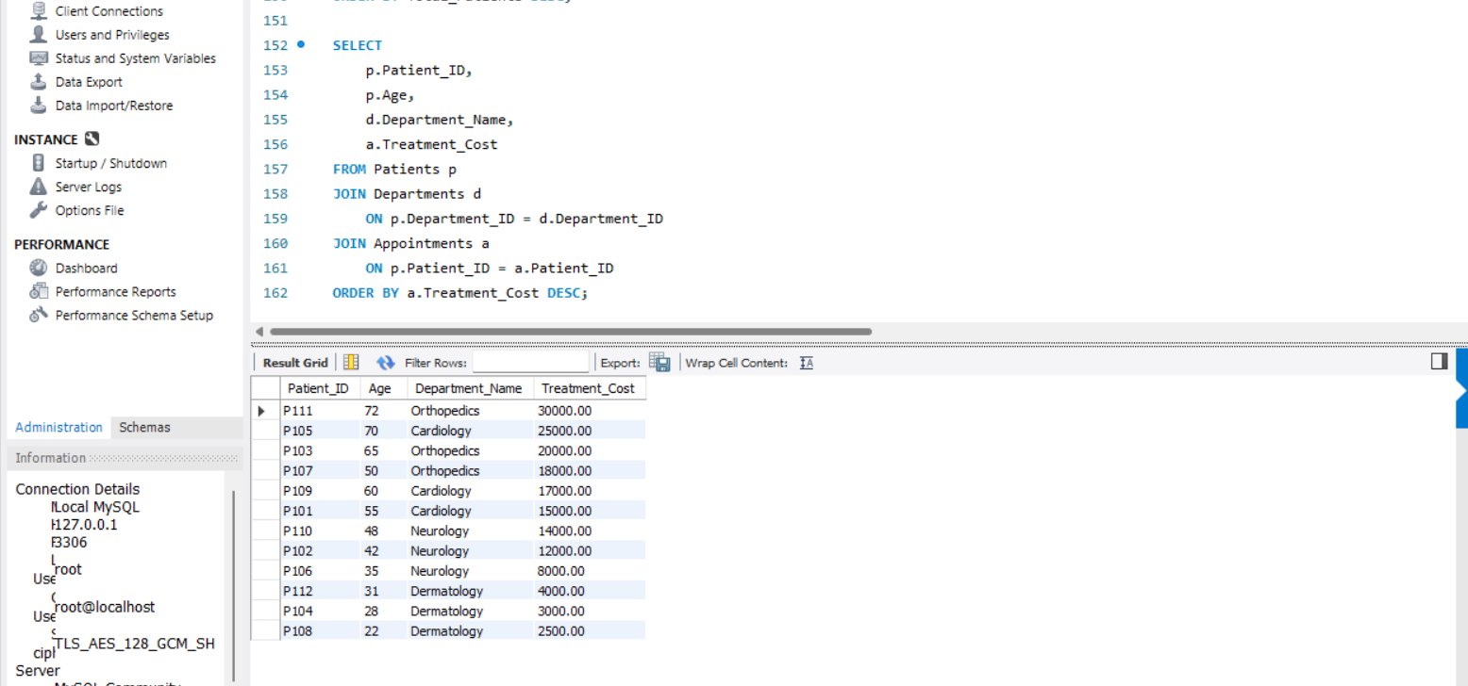

4.
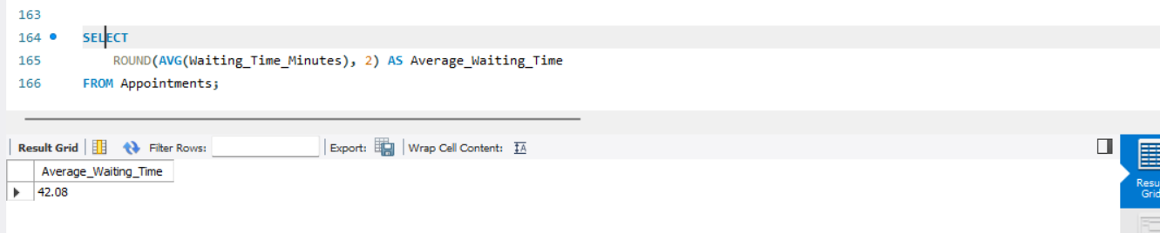
5.
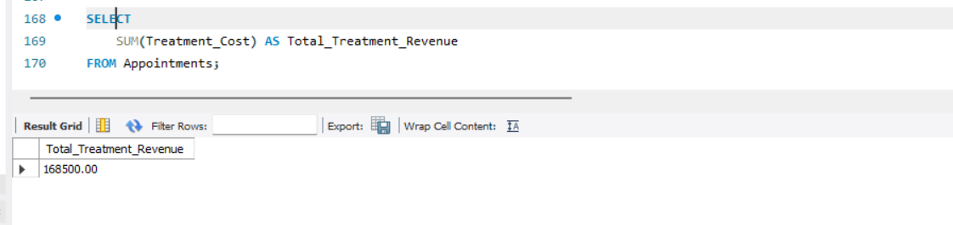
6.
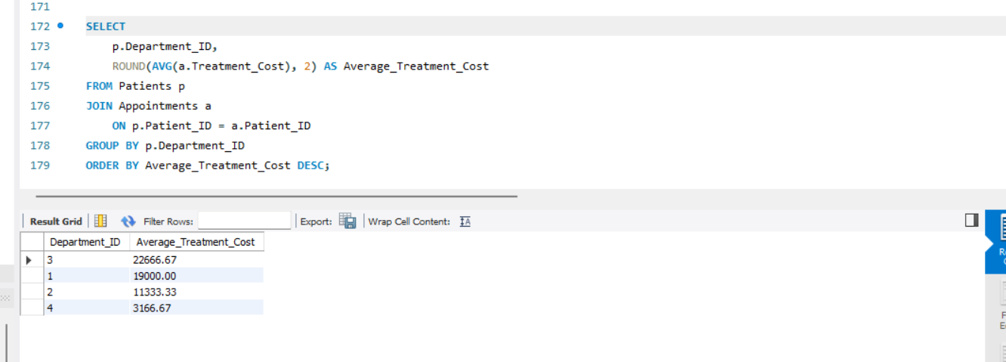
7.
